How to participate in ScanStar 2021
An entry form describing each entered packaging product must be ﬁlled by June 1 on http://gillet.nu/scanstar-2021/
Entry fee (1000 €) to be paid by invoice.

ScanStar is a joint Nordic packaging competition held annually since 1969 by SPA, the Scandinavian Packaging Association. Scanstar 2021 is organized by Swedish Packaging Guild (Svenska Förpackningsgillet).

Companies awarded a ScanStar gets a diploma and the right to use the ScanStar logo in the marketing of the awarded packaging. The names of the winners will be published internationally shortly after the jury decision. Packaging awarded a ScanStar has the right to enter the international
Entries must be sent by post by June 4, in three specimens: One of them should be ﬁlled (if possible) and the other two should be empty. The entries must be custom cleared with no costs for the receiver.
Address for competition entries: Zerust AB
Choose the aspect your product Judging criteria -Packaging products may
should be judged by: be entered by the following categories:
- A new idea /a new application - Consumer packaging
- Protections ability - Transport /distribution packaging
- Price/ cost savings - Other packaging
- User friendliness
- Design
- Environment
Attn: Magnus Sidling
Jolengatan 19
SE-431 49 Mölndal, Sweden

WorldStar competition arranged by World Packaging Organization (WPO).

Who can participate?
The competition is open for all packaging solutions designed, constructed or manufactured in one of the Nordic Countries. Packaging solutions made in other countries but sold by a Nordic company or ordered by a Nordic customer may also participate. Packaging entries must be marketed before the entry date and must not have been in any previous ScanStar competitions.

Entries can be made by designers, constructors, manufacturers or buyers of packaging with an approval from the other stakeholders. Each company has the right to enter an unlimited number of packages that comply with the rules of the competition.
scanstar@gillet.nu | www.gillet.nu | www.scanstar.org

Complete rules for the ScanStar Packaging Competition on www.scanstar.org

Contact: scanstar@gillet.nu or +46 76 88 44 060

The winners will be presented August 31 and the price
ceremony will be held on during the fall 2021.
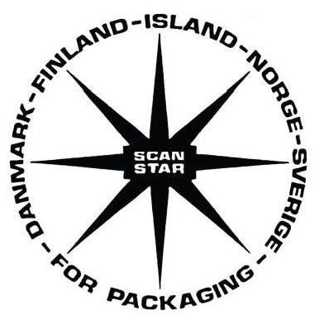

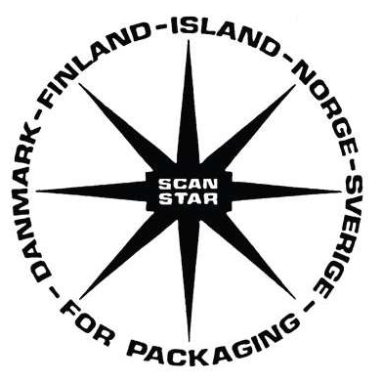

Invite

